CLOUD APPLICATION DEVELOPMENT

LANGUAGE TRANSLATOR CHATBOT DEPLOYMENT PROJECT

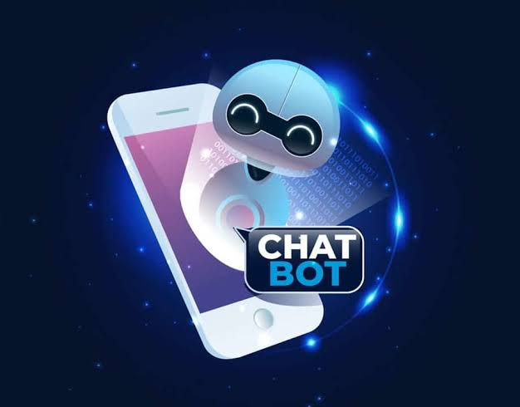 ON THE PART OF :

M.ASHWATHY

M.CHANDRU

V.ABISHA

V.LAKSHMIPRIYA

M.NANDHINI

Language Translator chatbot with

IBM cloud Watson Assistant

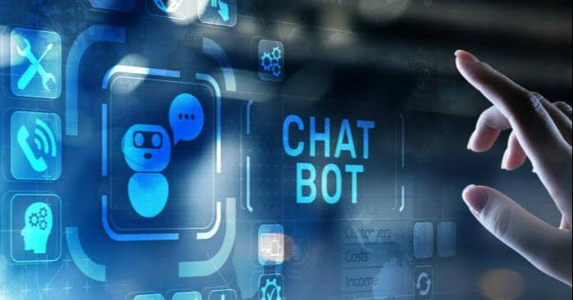

**Abstract:**

The “Language Translation Chatbot with IBM Watson Assistant” project is designed to address the persistent challenges posed by language barriers in our increasingly interconnected world. Leveraging the power of IBM Watson Assistant and cloud-based language translation services, this project aims to create an innovative and accessible chatbot capable of swiftly and accurately translating text between multiple language pairs. The project encompasses a series of meticulously planned steps, from setting up the IBM Cloud environment to the deployment of a user-friendly interface. Beyond breaking down language barriers, this chatbot embodies the potential of cutting-edge technology to foster global communication, facilitate learning, and promote inclusivity across diverse contexts. Through a commitment to continuous improvement, rigorous testing, and comprehensive user support, this Language Translation Chatbot stands as a testament to thetransformative possibilities of AI and cloud computing in overcoming linguistic divides.

**Introduction**:

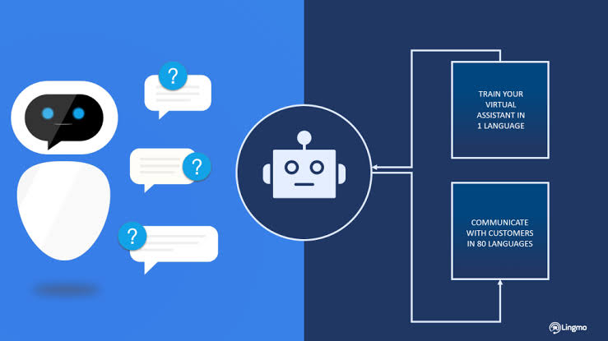In our increasingly interconnected world, language barriers often hinder effective communication and collaboration across borders and cultures. To address these challenges, the “Language Translation Chatbot with IBM Watson Assistant” project endeavors to create an innovative and accessible solution. By harnessing the formidable capabilities of IBM Watson Assistant and cloud-based language translation services, this project seeks to develop a user-friendly chatbot capable of swiftly and accurately translating text across multiple language pairs. Beyond mere translation, this chatbot represents a testament to the transformative potential of cutting-edge technology in enhancing global communication, promoting inclusivity, and facilitating learning in diverse contexts. Through continuous improvement, rigorous testing, and unwavering commitment to comprehensive user support, the Language Translation Chatbot embodies the fusion of AI and cloud computing to bridge linguistic divides and bring the world closer together.

**Project Steps:**

1. Set Up IBM Cloud Account:

Start by creating an IBM Cloud account to access the necessary cloud services and resources.

2. Create IBM Watson Assistant Instance:

Establish an IBM Watson Assistant instance on the cloud to serve as the core of your chatbot's conversational capabilities.

3. Language Pair Selection:

Decide on the specific language pairs your chatbot will support, e.g., English to Spanish, French to German, etc.

4. Data Collection:

Gather parallel text data for the selected language pairs. This dataset will be crucial for training your translation models.

5. Train Language Translation Models:

Utilize IBM Watson Language Translator or similar services to train translation models for each language pair. Train these models using your collected data to ensure accuracy and context-awareness.

6. Integration with Watson Assistant:

Develop a connection between your trained translation models and IBM Watson Assistant. This may involve creating custom webhooks or API endpoints to send and receive translated text.

7. Conversation Flow Design:

Design the chatbot's conversation flows. Define how users will input text, how translations will be handled, and how responses will be presented. Use natural language understanding (NLU) to enhance conversation understanding.

8. Chatbot Logic Implementation:

Build the chatbot's logic within IBM Watson Assistant's dialog builder. Create intents, entities, and dialog nodes to manage user interactions and responses.

9. Testing and Refinement:

Thoroughly test your chatbot with diverse language inputs to ensure accurate translations and a seamless user experience. Continuously refine dialog nodes and training data based on user interactions.

10. User Interface Development:

Design an intuitive user interface for the chatbot, which can be a web application, integrated into an existing app, or a mobile app for convenient translation access.

11. Localization Support:

Consider adding support for multiple languages in the chatbot's user interface, allowing users to select their preferred language.

12. Security and Privacy Measures:

Implement robust security measures to protect user data, especially sensitive information, in accordance with data protection regulations.

13. Deployment:

Deploy your chatbot on a web server or a cloud platform, ensuring easy access for users.

14. Feedback and Continuous Improvement:

Encourage user feedback and actively work on enhancing translation accuracy and overall user experience based on insights.

15. Monitoring and Analytics:

Set up monitoring and analytics to track user interactions, identify common translation needs, and improve the chatbot's performance over time.

16. Documentation and Support : Provide comprehensive user documentation and customer support to assist users in utilizing the Language Translation Chatbot effectively.

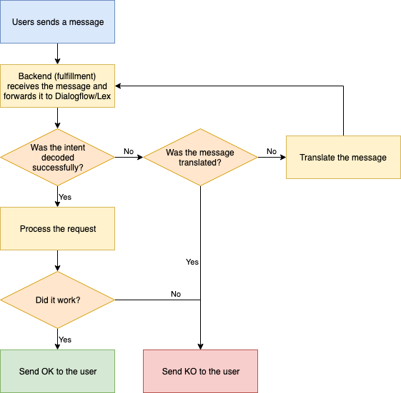

**PROCESS :**

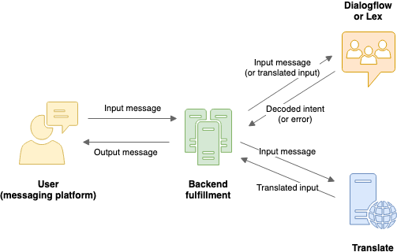

**Outcome:**

The Language Translation Chatbot using IBM Watson Assistant on the cloud will serve as a valuable tool for international travelers, language learners, and anyone in need of quick and accurate translations. It demonstrates the capabilities of IBM Watson in solving real-world communication challenges.

**Usefulness of the Language Translation Chatbot:**

The Language Translation Chatbot developed using IBM Watson Assistant on the cloud offers several valuable benefits:

1. Overcoming Language Barriers:The chatbot enables seamless communication between individuals who speak different languages. It breaks down language barriers, making it useful for international travelers, businesses with global customers, and multicultural communities.

2. Efficiency and Speed: With real-time translation capabilities, the chatbot provides quick and accurate translations, eliminating the need for manual language translation efforts. This saves time and enhances communication efficiency.

3. Accessibility:It ensures that information and services are accessible to a broader audience regardless of their language proficiency. This inclusivity is particularly important for education, healthcare, customer support, and social interactions.

4. Language Learning: Language learners can use the chatbot to practice and improve their language skills. By receiving translations and explanations, users can understand and learn new languages more effectively.

5. Travel Assistance: Travelers can rely on the chatbot to help them navigate foreign countries, read menus, understand street signs, and communicate with locals, making their journeys more enjoyable and hassle-free.

6. Multilingual Customer Support: Businesses can integrate the chatbot into their customer support systems, allowing customers to interact in their preferred language. This enhances customer satisfaction and fosters international customer relationships.

7. Accessibility for Hearing-Impaired: The chatbot can also assist individuals with hearing impairments by providing text-based translations of spoken language, making communication more accessible.

8. Cost Savings: By automating language translation processes, businesses can reduce the need for human translators, which can result in cost savings, especially for frequently translated content.

9. Privacy and Convenience: Users can seek translations privately through the chatbot, which can be important for sensitive conversations and personal information sharing.

10.Continuous Improvement: Through user feedback and data analytics, the chatbot can continuously improve its accuracy and adapt to user needs, ensuring that it remains a valuable tool for language-related challenges.

Language Translation Chatbot addresses real-world communication barriers, enhances accessibility, saves time and resources, and contributes to a more connected and inclusive global community. Its usefulness extends across various domains, making it a versatile solution for language-related challenges in today's interconnected world.

**Conclusion :**

In summary, the “Language Translation Chatbot with IBM Watson Assistant" project is a testament to the power of technology in breaking down language barriers and promoting global communication. It encompasses a journey from project initiation and cloud setup to chatbot development, integration, and deployment. With a focus on user experience, security, and continuous improvement, this chatbot serves as a valuable tool for international travelers, language learners, businesses, and diverse communities. It embodies the potential of AI and cloud computing to connect people across languages, making our world more inclusive and accessible.